

Submitted by : Spogmai jan

Roll no : 2430 - 0081

Submitted to : Sir Bilal dar

Subject : dld

Assignment no : 03

1. Implement The Gray code to Binary converter is verified.

XOR truth table :

|  |  |  |
| --- | --- | --- |
| A | B | A XOR B |
| 0 | 0 | 0 |
| 0 | 1 | 1 |
| 1 | 0 | 1 |
| 1 | 1 | 0 |

**XOR**

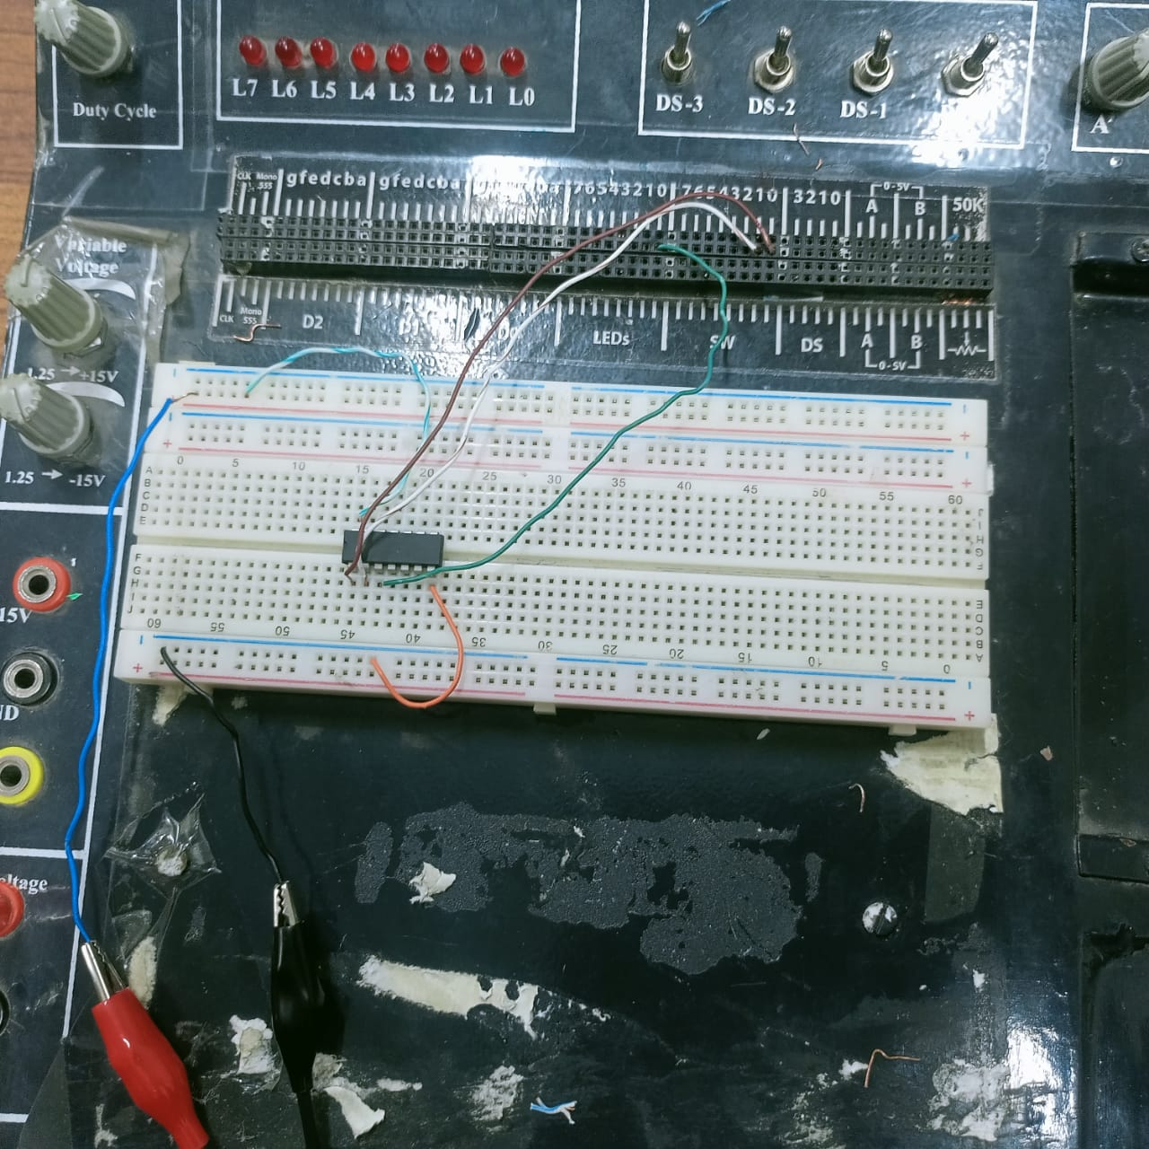

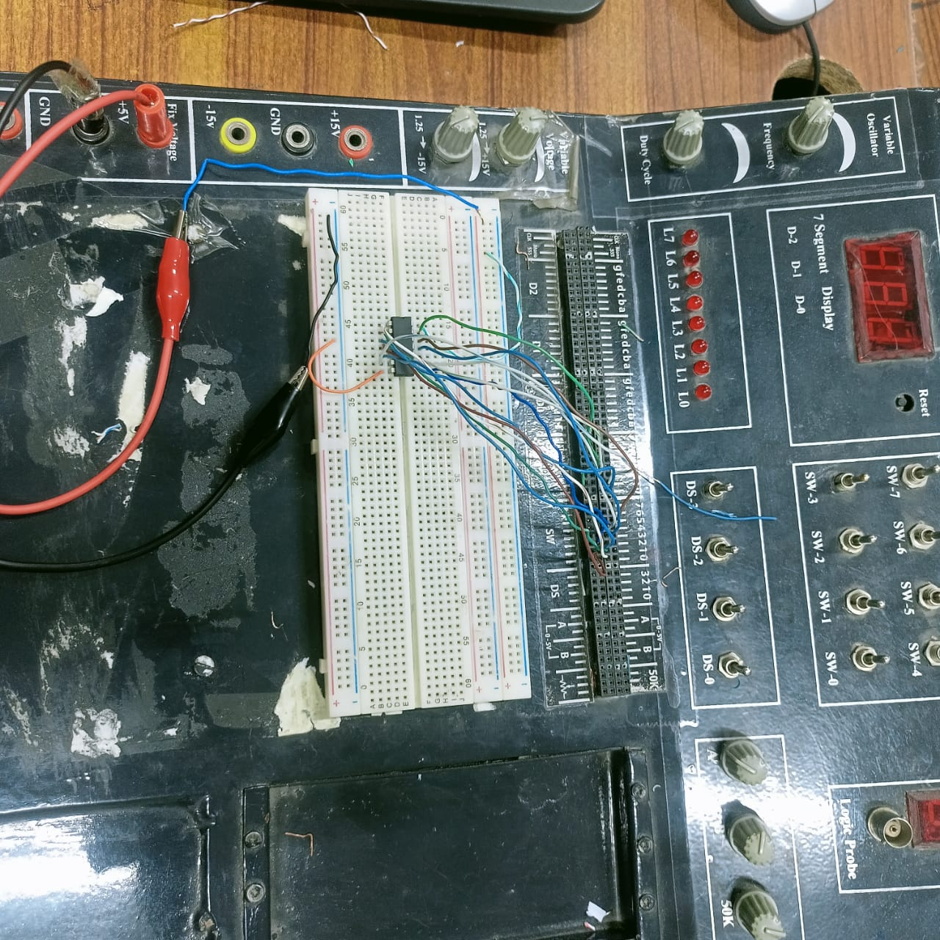

**LED 0 :**

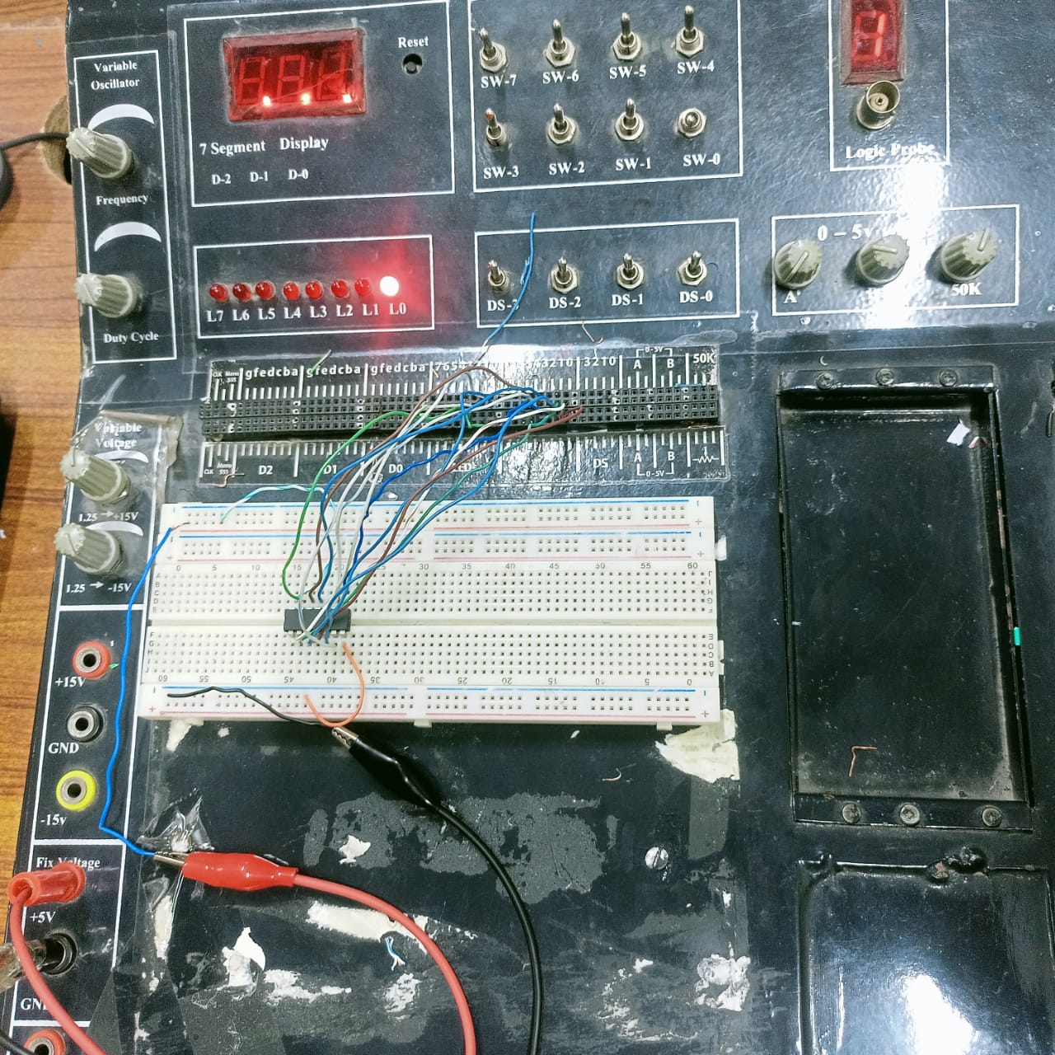

**LED 1 :**

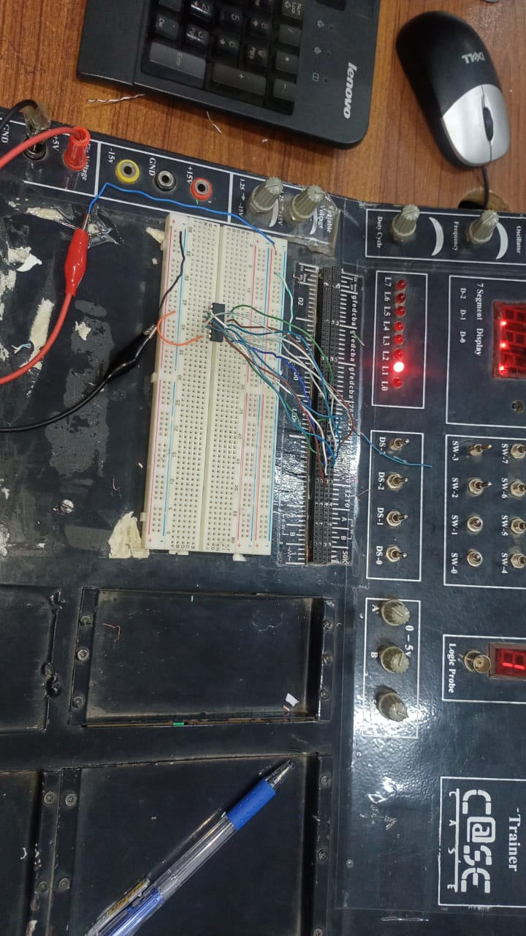

1. Implement The Binary code to Gray converter is verified.

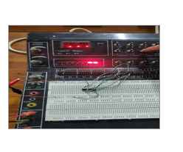

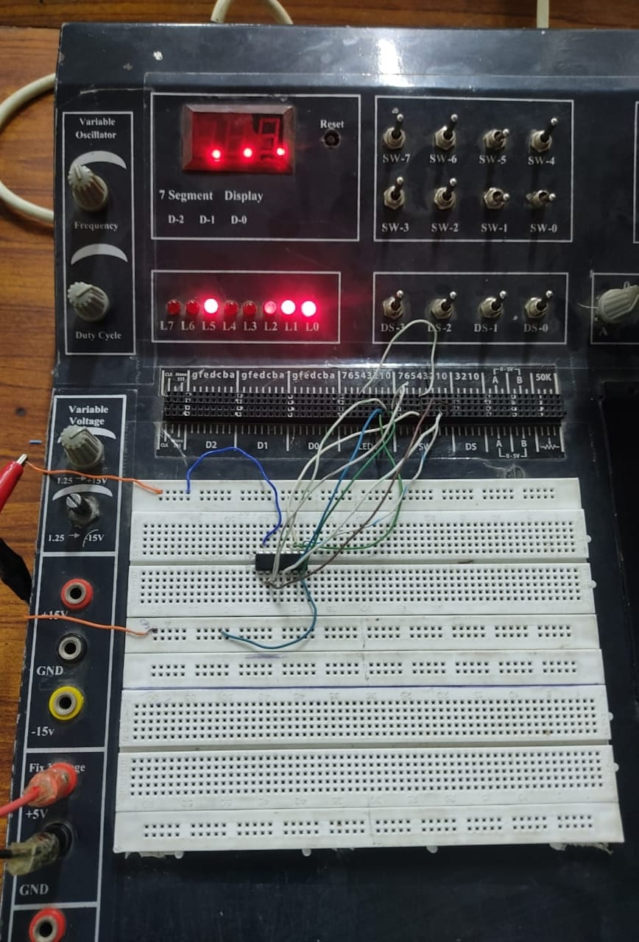

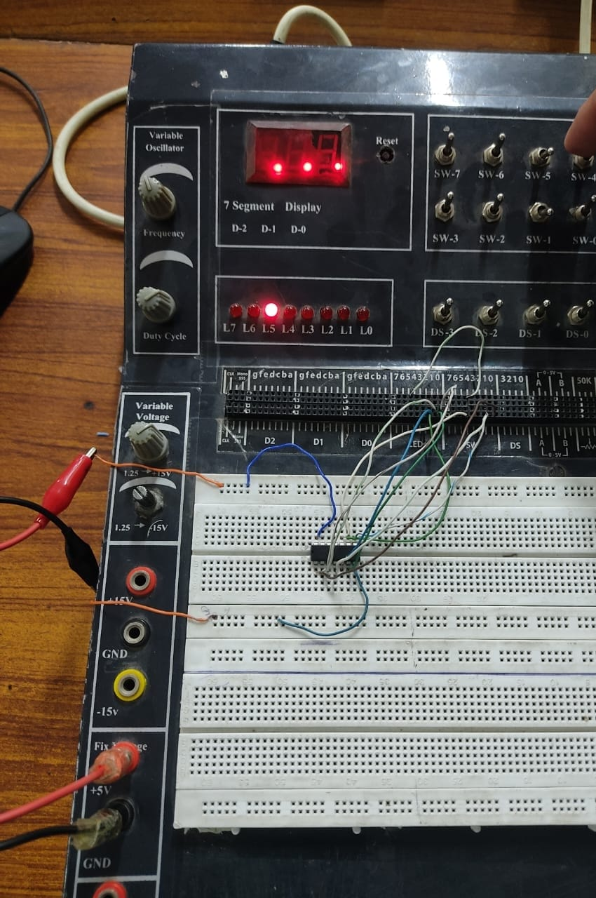

----- THE END ----